FSM :

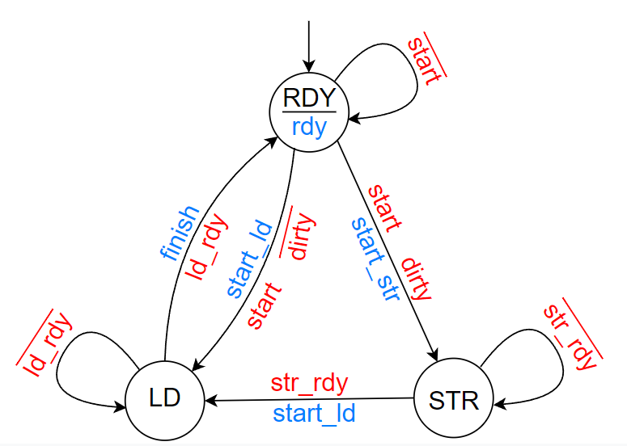
Transition Table :
S₁ | S₀ |  | Start | dirty | Str rdy | Ld rdy |  | S₁ | S₀
0 | 0 |  | 0 |  |  |  |  | 0 | 0
0 | 0 |  | 0 |  |  |  |  | 0 | 0
0 | 0 |  | 0 |  |  |  |  | 0 | 0
0 | 0 |  | 0 |  |  |  |  | 0 | 0
0 | 0 |  | 0 |  |  |  |  | 0 | 0
0 | 0 |  | 0 |  |  |  |  | 0 | 0
0 | 0 |  | 0 |  |  |  |  | 0 | 0
0 | 0 |  | 0 |  |  |  |  | 0 | 0
0 | 0 |  | 1 | 0 |  |  |  | 1 | 0
0 | 0 |  | 1 | 0 |  |  |  | 1 | 0
0 | 0 |  | 1 | 0 |  |  |  | 1 | 0
0 | 0 |  | 1 | 0 |  |  |  | 1 | 0
0 | 0 |  | 1 | 1 |  |  |  | 0 | 1
0 | 0 |  | 1 | 1 |  |  |  | 0 | 1
0 | 0 |  | 1 | 1 |  |  |  | 0 | 1
0 | 0 |  | 1 | 1 |  |  |  | 0 | 1
0 | 1 |  |  |  | 0 |  |  | 0 | 1
0 | 1 |  |  |  | 0 |  |  | 0 | 1
0 | 1 |  |  |  | 1 |  |  | 1 | 0
0 | 1 |  |  |  | 1 |  |  | 1 | 0
0 | 1 |  |  |  | 0 |  |  | 0 | 1
0 | 1 |  |  |  | 0 |  |  | 0 | 1
0 | 1 |  |  |  | 1 |  |  | 1 | 0
0 | 1 |  |  |  | 1 |  |  | 1 | 0
0 | 1 |  |  |  | 0 |  |  | 0 | 1
0 | 1 |  |  |  | 0 |  |  | 0 | 1
0 | 1 |  |  |  | 1 |  |  | 1 | 0
0 | 1 |  |  |  | 1 |  |  | 1 | 0
0 | 1 |  |  |  | 0 |  |  | 0 | 1
0 | 1 |  |  |  | 0 |  |  | 0 | 1
0 | 1 |  |  |  | 1 |  |  | 1 | 0
0 | 1 |  |  |  | 1 |  |  | 1 | 0
1 | 0 |  |  |  |  | 0 |  | 1 | 0
1 | 0 |  |  |  |  | 1 |  | 0 | 0
1 | 0 |  |  |  |  | 0 |  | 1 | 0
1 | 0 |  |  |  |  | 1 |  | 0 | 0
1 | 0 |  |  |  |  | 0 |  | 1 | 0
1 | 0 |  |  |  |  | 1 |  | 0 | 0
1 | 0 |  |  |  |  | 0 |  | 1 | 0
1 | 0 |  |  |  |  | 1 |  | 0 | 0
1 | 0 |  |  |  |  | 0 |  | 1 | 0
1 | 0 |  |  |  |  | 1 |  | 0 | 0
1 | 0 |  |  |  |  | 0 |  | 1 | 0
1 | 0 |  |  |  |  | 1 |  | 0 | 0
1 | 0 |  |  |  |  | 0 |  | 1 | 0
1 | 0 |  |  |  |  | 1 |  | 0 | 0
1 | 0 |  |  |  |  | 0 |  | 1 | 0
1 | 0 |  |  |  |  | 1 |  | 0 | 0

States Formulas :

S₁ = S₁S₀SD + S₁S₀R + S₁S₀L
S₀ = S₁S₀SD + S₁S₀R

Output Table :

S₁ | S₀ |  | Start | dirty | Str rdy | Ld rdy |  | SR | SL | finish
0 | 0 |  | 0 |  |  |  |  | 0 | 0 | 0
0 | 0 |  | 0 |  |  |  |  | 0 | 0 | 0
0 | 0 |  | 0 |  |  |  |  | 0 | 0 | 0
0 | 0 |  | 0 |  |  |  |  | 0 | 0 | 0
0 | 0 |  | 0 |  |  |  |  | 0 | 0 | 0
0 | 0 |  | 0 |  |  |  |  | 0 | 0 | 0
0 | 0 |  | 0 |  |  |  |  | 0 | 0 | 0
0 | 0 |  | 0 |  |  |  |  | 0 | 0 | 0
0 | 0 |  | 1 | 0 |  |  |  | 0 | 1 | 0
0 | 0 |  | 1 | 0 |  |  |  | 0 | 1 | 0
0 | 0 |  | 1 | 0 |  |  |  | 0 | 1 | 0
0 | 0 |  | 1 | 0 |  |  |  | 0 | 1 | 0
0 | 0 |  | 1 | 1 |  |  |  | 1 | 0 | 0
0 | 0 |  | 1 | 1 |  |  |  | 1 | 0 | 0
0 | 0 |  | 1 | 1 |  |  |  | 1 | 0 | 0
0 | 0 |  | 1 | 1 |  |  |  | 1 | 0 | 0
0 | 1 |  |  |  | 0 |  |  | 0 | 0 | 0
0 | 1 |  |  |  | 0 |  |  | 0 | 0 | 0
0 | 1 |  |  |  | 1 |  |  | 0 | 1 | 0
0 | 1 |  |  |  | 1 |  |  | 0 | 1 | 0
0 | 1 |  |  |  | 0 |  |  | 0 | 0 | 0
0 | 1 |  |  |  | 0 |  |  | 0 | 0 | 0
0 | 1 |  |  |  | 1 |  |  | 0 | 1 | 0
0 | 1 |  |  |  | 1 |  |  | 0 | 1 | 0
0 | 1 |  |  |  | 0 |  |  | 0 | 0 | 0
0 | 1 |  |  |  | 0 |  |  | 0 | 0 | 0
0 | 1 |  |  |  | 1 |  |  | 0 | 1 | 0
0 | 1 |  |  |  | 1 |  |  | 0 | 1 | 0
0 | 1 |  |  |  | 0 |  |  | 0 | 0 | 0
0 | 1 |  |  |  | 0 |  |  | 0 | 0 | 0
0 | 1 |  |  |  | 1 |  |  | 0 | 1 | 0
0 | 1 |  |  |  | 1 |  |  | 0 | 1 | 0
1 | 0 |  |  |  |  | 0 |  | 0 | 0 | 0
1 | 0 |  |  |  |  | 1 |  | 0 | 0 | 1
1 | 0 |  |  |  |  | 0 |  | 0 | 0 | 0
1 | 0 |  |  |  |  | 1 |  | 0 | 0 | 1
1 | 0 |  |  |  |  | 0 |  | 0 | 0 | 0
1 | 0 |  |  |  |  | 1 |  | 0 | 0 | 1
1 | 0 |  |  |  |  | 0 |  | 0 | 0 | 0
1 | 0 |  |  |  |  | 1 |  | 0 | 0 | 1
1 | 0 |  |  |  |  | 0 |  | 0 | 0 | 0
1 | 0 |  |  |  |  | 1 |  | 0 | 0 | 1
1 | 0 |  |  |  |  | 0 |  | 0 | 0 | 0
1 | 0 |  |  |  |  | 1 |  | 0 | 0 | 1
1 | 0 |  |  |  |  | 0 |  | 0 | 0 | 0
1 | 0 |  |  |  |  | 1 |  | 0 | 0 | 1
1 | 0 |  |  |  |  | 0 |  | 0 | 0 | 0
1 | 0 |  |  |  |  | 1 |  | 0 | 0 | 1

Output Formulas :

Start Store = S₁S₀SD
Start Load = S₁S₀SD + S₁S₀R
Finishing = S₁L

